Top 20 Git Commands with Example

[Go to the profile of Saurabh Kulshrestha](https://medium.com/@saurabh_86037?source=post_header_lockup)

[Saurabh Kulshrestha](https://medium.com/@saurabh_86037)Follow

Jul 23, 2018

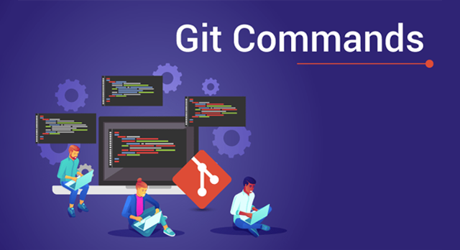

Git Commands — Edureka

Git & GitHub has steadily risen from being just a preferred skill to a must-have skill for multiple job roles today. In this article, I will talk about the Top 20 Git Commands that you will be using frequently while you are working with Git.

Following are the Git commands which are being covered:

* git config
* git init
* git clone
* git add
* git commit
* git diff
* git reset
* git status
* git rm
* git log
* git show
* git tag
* git branch
* git checkout
* git merge
* git remote
* git push
* git pull
* git stash

So, let’s get started now!!

**git config**

**Usage: git config -global user.name “[name]”**

**Usage: git config -global user.email “[email address]”**

This command sets the author name and email address respectively to be used with your commits.

https://cdn-images-1.medium.com/max/1000/1*8HUmCSPeXDzPg7SXt07QQA.png

**git init**

**Usage: git init [repository name]**

This command is used to start a new repository.

https://cdn-images-1.medium.com/max/1000/1*dWnCmhEhNO9fKt1ThV0v8A.png

**git clone**

**Usage: git clone [url]**

This command is used to obtain a repository from an existing URL.

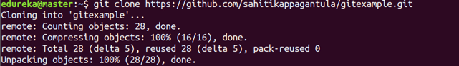

**git add**

**Usage: git add [file]**

This command adds a file to the staging area.

https://cdn-images-1.medium.com/max/1000/1*P2An1Y9NCCjFKYqOotfKxQ.png

**Usage: git add \***

This command adds one or more to the staging area.

https://cdn-images-1.medium.com/max/1000/1*j4vMw9vJlJmk_pzK-BgRAQ.png

**git commit**

**Usage: git commit -m “[ Type in the commit message]”**

This command records or snapshots the file permanently in the version history.

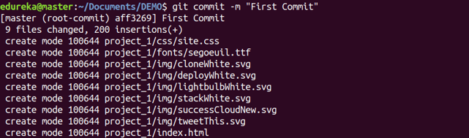

**Usage: git commit -a**

This command commits any files you’ve added with the git add command and also commits any files you’ve changed since then.

https://cdn-images-1.medium.com/max/1000/1*icxzIA5Ues4vDIB5GxsxiA.png

**git diff**

**Usage: git diff**

This command shows the file differences which are not yet staged.

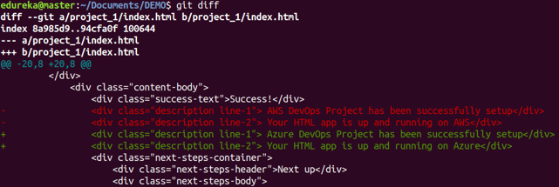

**Usage: git diff –staged**

This command shows the differences between the files in the staging area and the latest version present.

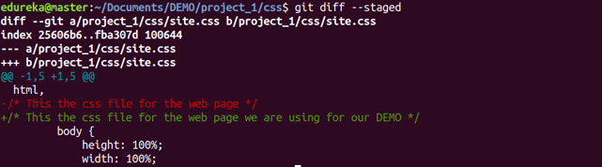

**Usage: git diff [first branch] [second branch]**

This command shows the differences between the two branches mentioned.

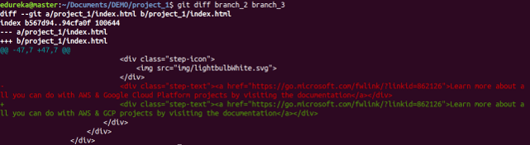

**git reset**

**Usage: git reset [file]**

This command unstages the file, but it preserves the file contents.

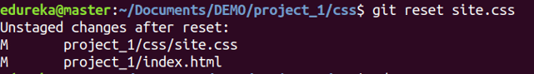

**Usage: git reset [commit]**

This command undoes all the commits after the specified commit and preserves the changes locally.

https://cdn-images-1.medium.com/max/1000/1*UxIbcPVz39tcze8g5zo74Q.png

**Usage: git reset -hard [commit]**

This command discards all history and goes back to the specified commit.

https://cdn-images-1.medium.com/max/1000/1*gTFoK5XixfM0DwHq4MxK6g.png

**git status**

**Usage: git status**

This command lists all the files that have to be committed.

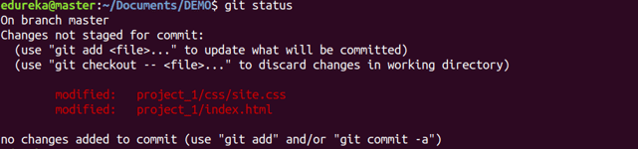

**git rm**

**Usage: git rm [file]**

This command deletes the file from your working directory and stages the deletion.

https://cdn-images-1.medium.com/max/1000/1*fYV7NUwxT0FH4_-2ES7Rdw.png

**git log**

**Usage: git log**

This command is used to list the version history for the current branch.

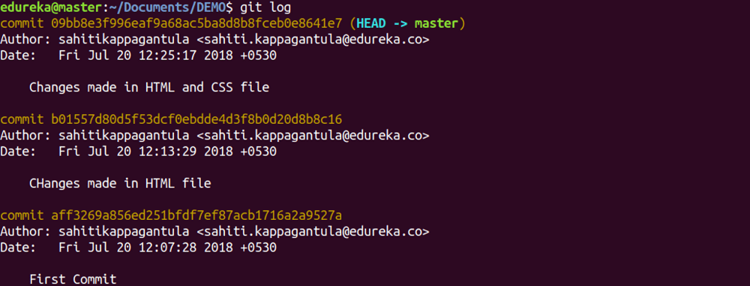

**Usage: git log -follow[file]**

This command lists version history for a file, including the renaming of files also.

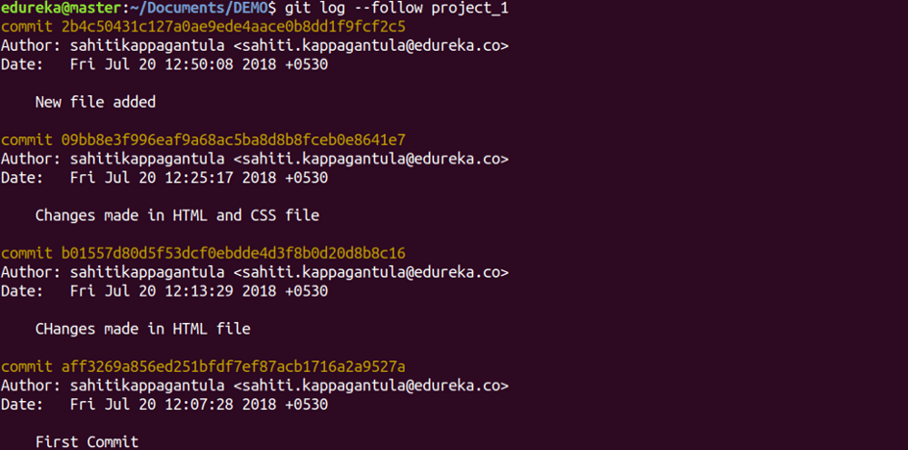

**git show**

**Usage: git show [commit]**

This command shows the metadata and content changes of the specified commit.

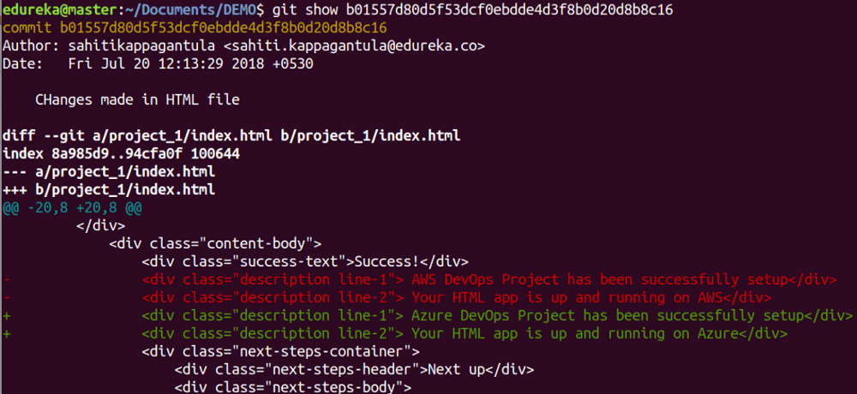

**git tag**

**Usage: git tag [commitID]**

This command is used to give tags to the specified commit.

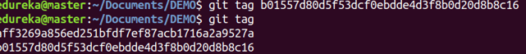

**git branch**

**Usage: git branch**

This command lists all the local branches in the current repository.

https://cdn-images-1.medium.com/max/1000/1*4xRndU8pT95BzNr4qBizYA.png

**Usage: git branch [branch name]**

This command creates a new branch.

https://cdn-images-1.medium.com/max/1000/1*9m0DaShOc5RcvPmwPg8h8g.png

**Usage: git branch -d [branch name]**

This command deletes the feature branch.

https://cdn-images-1.medium.com/max/1000/1*lIWOaErZzOk3uvT4aak9_A.png

**git checkout**

**Usage: git checkout [branch name]**

This command is used to switch from one branch to another.

https://cdn-images-1.medium.com/max/1000/1*jRGfXP4IPICYHXtmmJ4RHQ.png

**Usage: git checkout -b [branch name]**

This command creates a new branch and also switches to it.

https://cdn-images-1.medium.com/max/1000/1*4nn_D7_tT1kuPvWi88UdSw.png

**git merge**

**Usage: git merge [branch name]**

This command merges the specified branch’s history into the current branch.

https://cdn-images-1.medium.com/max/1000/1*QGsQYNhDzEzvjUlXI0FuZQ.png

**git remote**

**Usage: git remote add [variable name] [Remote Server Link]**

This command is used to connect your local repository to the remote server.

https://cdn-images-1.medium.com/max/1000/1*kVQ77mdtHApIpFPk1gbkPw.png

**git push**

**Usage: git push [variable name] master**

This command sends the committed changes of master branch to your remote repository.

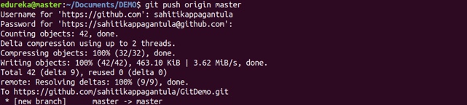

**Usage: git push -all [variable name]**

This command pushes all branches to your remote repository.

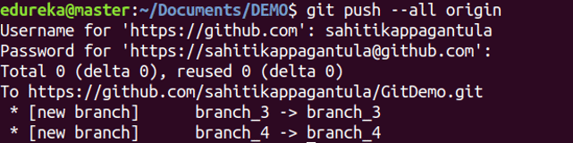

**Usage: git push [variable name] :[branch name]**

This command sends the branch commits to your remote repository.

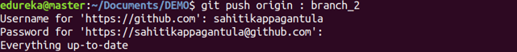

**git pull**

**Usage: git pull [Repository Link]**

This command fetches and merges changes on the remote server to your working directory.

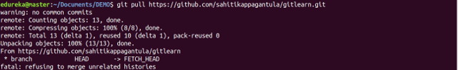

**git stash**

**Usage: git stash save**

This command temporarily stores all the modified tracked files.

https://cdn-images-1.medium.com/max/1000/1*5UAQr_erBnC6Fnda2rS0sw.png

**Usage: git stash pop**

This command restores the most recently stashed files.

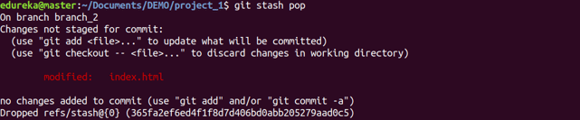

**Usage: git stash list**

This command lists all stashed changesets.

https://cdn-images-1.medium.com/max/1000/1*lqr8ZdO78ztoeomIBDFYBA.png

**Usage: git stash drop**

This command discards the most recently stashed changeset.

https://cdn-images-1.medium.com/max/1000/1*ZbCSi45lki09YdPCueuf-w.png

This brings us to the end o